Dasha Jones
Hailey Lynch
Mrs. Candela
Advanced Web Design
November 20, 2014
Light Up Our World
Introduction
“Darkness cannot drive out darkness: only light can do that. Hate cannot drive out hate: only love can do that." Michigan Council of Women in Technology has sparked us once again with another challenge called Repurposing! Our web design class required us to make a website from scratch and make it look wicked awesome using the new codes we learned. With this theme we were instructed to pick three items we would like to repurpose, explain how to make the repurposed item, what cause the item would help and what it will be turned in to. Ever since the announcement online, Hailey and I have been bursting with ideas. While researching what to repurpose at school and at home, we have learned why we need to appreciate our family and the world around us. We have learned how we can improve what we love most. First, we light a candle for Hailey's grandmother, who makes yummy cupcakes, with the softest whipped icing. Then we light one for Dasha’s brother who makes delectable, gigantic pancakes that melt in your mouth. We light our last candle for the rapidly changing world around us. The world could be so much cleaner if we repurposed items that we use daily. Within our website, we have decided to repurpose a log hollowed out into a candle holder, creating this beautiful dim light, new ways to light the dark with a simple household whisk, and what you can do to decorate the boring spoons in your kitchen! Hopefully this website will inspire others to appreciate who and what they have already and how to make old items into new, improved items.
Index
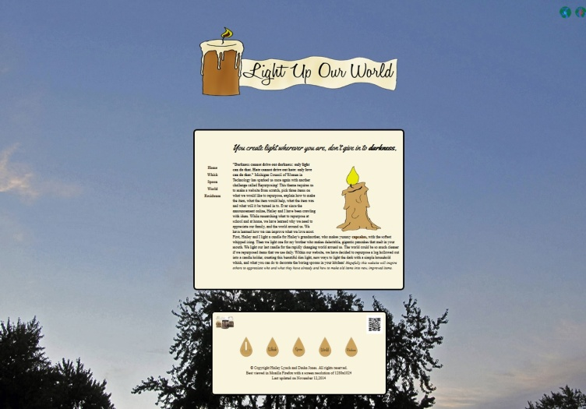
The purpose of our website is to give people an idea of how sentimental little things can be. Also, it helped us understand that we don’t only take people for granted but also old items. The index is the introductory page of the website and lets people know what the website is about. The color scheme for our website takes after the colors of candle wax, before it melts and after. Our logo was originally our main picture, but we made it into the banner and it looked neat and we both liked it. Our favicon is actually just half of tree with no leaves we had our friend, Sabrina Reinhard, draw. She did not like how it looked so she left it unfinished. After Dasha and I looked at it for a little bit we decided it would be cool as a favicon, so we worked with it in Photoshop and it come out nice! Our cursor was just a simple arrow with a plus sign, we just could not get that picture icon for a cursor and we were devastated. Our social media did not start off too good; no one wanted to follow us so Hailey went around her entire lunch asking people to follow us, but we finally decided to do a Twitter and a Pinterst. Sabrina drew both of the icons for them. We decided to go for a professional look with the placement of our social media and our QR code for the MCWT website. While making our index page we had our rollovers in the footer as our main navigation. They were really big, but we did not know how to fix it or make it look better. So, finally one day we decided to look up a whole bunch of navigation coding and websites with good navigation. We finally decided on our current navigation. We were so happy when we found out codes to make it possible. However, with the navigation coding we wanted navigation in the middle table left aligned. It was especially horrible on our Residuum page, because it was so long due to our table explaining our technology classes, and our survey. We were determined to fix the unacceptable navigation and we began searching for ways to fix it. After long days and nights, we found a code that was more than simple. We could not believe we did not find it before. All we had to do was vertically align it to the top. We were so ecstatic when it looked perfect on our website! When our index page was done we knew the rest of the designing would be easier.
Whisk
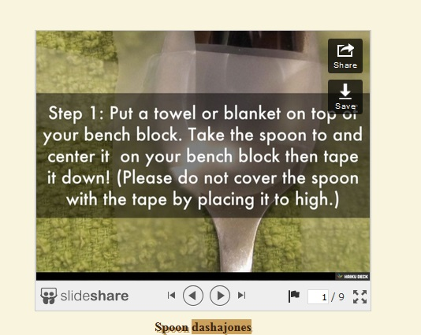
One of the code’s we struggled with was our slide show code from Dynamic Drive, and honestly it was one of the coolest codes introduced to us. We had three examples to pick from of simple slides we picked the first example, as Hailey and I always are just simple. And it was easy at first until we had double arrows underneath our slide, which when you clicked the arrows they would bounce up to the top of the page; I mean it would have been a cool back to the top button but it was not needed in this case. So Hailey and I went through the code so many times to see where we could have messed up, we figured there was a double code somewhere in this word maze, but we could not find anything. Also the code did not work in all browsers and yes, you would think it would work internet explorer but not at all. Some days our slide show would work and sometimes it was just a black sad screen. This slide show began to slow down the time it took for our web page to load. It frustrated us that some of the women in the class slide shows popped up just fine in all web browsers! We thought it was just a simple mistake so we asked our teacher, Mrs. Candela, to take it a look. Come to find out, a lot of class was having the same problems. To add to our devastation, we had to be directed to a different code due to not be able to fix this conundrum. Crazy, I know, Hailey and I just could not pick between the codes, so we have two favorite codes to share! Hailey always pays attention to the little things which is good because that really makes our page POP. Her favorite code would be the CSS class code that she put on our links. The links on our page create a shadow when you hover of it, and when you have visited the the link it makes a slash through it like you checked off an item on your grocery list. Our links are brown because this is the color scheme of our page, but they also have this radiant shadow effect. Now I picked the survey code which is a embed code but it still counts. I love to hear feedback from my peers, my family, coworkers, and don’t forget the judges. Every morning in class Hailey and I check Google forms everyday to see what new responses we have received this code really tugs at me personally because I get to see what other’s feel about my site; which always a plus. The questions were aimed directly toward a critique questioning just I can see what we could have improved on, what we did that was impressive. I love going back and rendering my mistakes and ideas so they won’t just apply to me but can apply to everyone
Spoon
We decided to place our video on the third page, the spoon. Our theme of the site is to light up our world with your respect, love and actions. Our page shows a sentimental message of the love we have for our family and the world we live in. We came up with this video of our loved ones saying that they love us, because I felt that it brought our page together. We wanted to put the video on the index page at first, but no one would know who that woman was or that guy in the army uniform, so we decided not to add the video until the audience read both the whisk and spoon page. So when they decided to watch the video, they will have a better understanding. We were actually able to go to Partridge Creek and attend a lesson with the Apple crew. These 4 women were very sweet; they went through every step of creating a video in iMovie. If you needed help or did not understand they quickly came over to help you get our video to perfection. Since our page is so simple we decided not to add a theme to our video, we wanted it to be plain with simple transitions with subtitles. We also decided not to add music so you could hear Hailey’s grandma and my brother talk.
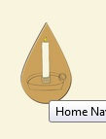
World
We had so many ideas for our animation literally thinking of everything. Originally we wanted our animation to be our main picture on our index page with a candle flickering from left to right. Hailey and I both didn’t have any artistic ability so we couldn’t draw a candle, and all of our Vincent Van Gogh friends were too busy with homework to draw the picture for us: so we were in a sticky situation. Hailey and I had to go search through our folders in each of computers and look for a picture we haven’t used! Which is hard because we used almost every drawn picture our friends gave us but we ended up finally our lucky tree. This tree would represent our third page about respecting the world and making it in to a better place for others. When the season changes from summer to fall the leaves slowly fall the winds become stronger and we get goose bumps from the chills in the air. Our moving leaves represent change, a change in people and a change in seasons. The animation process was much easier than last year using CS6! The hardest process was just getting the leaves to move at the same time but also in different directions. So each leaf I moved a couple inches from left to right or up and down. I then took the yellow diamond and put starts and stops in the time line of each leaf. Good thing everything worked out fine and I got the leaves the move right way I enjoy watching it play over and over again.
Residuum
Once we started our webmaster page, we knew it was all coming to an end. We decided to call the page something other than, ‘About Us’ or ‘Getting to Know Us.’ We wanted something different, something so rare no one would be expecting it. With a little bit of research we settled on naming our page ‘Residuum’ which we misspelled many times and had to go back. Our residuum page contains everything that a regular about me page would contain, including super awesome survey and citations. We had quite a few citations and we are thankful for every single one. However, we both agree out favorite and most valuable resource was W3 Schools. Whenever we had trouble with a code or felt like we needed something extra help W3 Schools was always there for us. It is a very organized and easy self-explainable website it shows you were to insert the code and what the outcome should look like which was extremely helpful. All 6 of the NETS benchmarks were met in this class. Creativity and Innovation, the first benchmark, it is not hard to meet this requirement. Everything we do in this class requires creativity which is what w embodied and strived for throughout this site. The second benchmark is communication and collaboration, which is very important, especially because we had to work together in a partnership. We used the research and information and fluency benchmark, because code we learned we had to look up and see what else we could do with it. We spent a lot of time searching for new and more advanced codes. Digital citizenship was definitely used because we had to comment on each other’s Weebly blogs and give constructive criticism. We spend every day with the computers and technology; we most certainly achieved benchmark 6, Technology operations and concepts. However, the most important benchmark is benchmark 5, Critical thinking, problem solving, and decision making. In this class we were on our own a lot, we had to search codes and fix our own mistakes. It was really hard at first, because we constantly wanted to ask for help. But, we knew we could not, because we had to figure things out on our own. Our navigation is a prime example, because we found it on our own and we had to find ways to play with it and fix its problems on our own. We hit all the benchmark points and we paid special attention to the most important ones. But most of all we learned the cool codes and we had fantastic fun!
Conclusion
What we enjoyed about the web design process was working in a partnership both times Hailey and I did the contest we were solo. This was a huge change for us, to depend on each other to make sure the work was completed. Which wasn’t hard for us at all, we never clashed ideas. Hailey would always add on to my ideas or I would at on to hers. We had constant ideas flowing back and forth; the only thing we had to determine was how to incorporate those ideas into the site. I feel like our weakness is deadlines, we are always rushing to complete something and that’s why it is usually wrong. If we took the time to look over our work we would not have complications. Another weakness is trying to be unique if we saw someone whose site was similar or had a similar trait at that exact moment we would change ours or think of ways it could be different instead of letting it go and just remaining the same. Our strengths are hard work and dedication we work hard on everything we put on this website. Hailey would take the code home without the pictures and work on the code. Sometimes I was not near a computer and Hailey needed the revised code I would open notes and do the code on my phone. We have really put so much time and effort into this site. If we could redo our website we would change the color scheme, only because it so simple and boring. It reminds us of the boring “Spongebob Squarepants” episode. Our page does not need to be neon colors, but just little colors that pop to brighten our site’s atmosphere. We would never change our navigation! We wanted that side navigation so bad and Hailey searched far and wide on how to do it! To this very day even though we are done with our websites Hailey and I look back and smile on the day that she found it. This project is our grade for the trimester, we work on this one project for an entire three months, and then we are put into a contest to win money. Having to share all of this responsibility with another person and actually succeeding in completing this site is almost unreal. Before this project I would never allow someone to have such a big impact on my grade but after this I am willing to do it again. If the person has hard work ethic and a dedication to win, why would I not share the work with them? So in college Hailey and I will not be scared to partner up with others on huge projects as long as they have the key traits to succeeding. This class has chosen our career path we are now sure on what we want to do in life. It has added meaning because we are not undecided college freshman. We now know what we are working towards, we know what we want to accomplish. This has benefited us in so many ways especially in diversity you sit in class and indulge everyone’s ideas on one theme. No one’s ideas are the same everyone is unique and the cool thing about that is there is about 20 kids in the class. We are able to look through our peers sites and give advice, what could be better, what they could change, what they should not change. Being able to help your competitors out is something so big to us; this has changed us as people. The greed to win money is no longer there, it is now greed to succeed and help others along the way.

