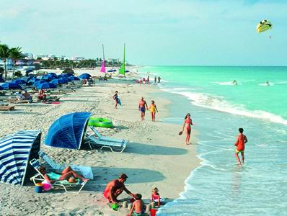

1. **Live In Chicago.**
2. **Go On A Safari.**
3. **Visit Miami.**
4. **Go Shopping In New York.**
5. **Go Back Stage With A Famous Singer/Rapper I Like.**
6. **Get Called On Stage With The Singer Or Rapper.**
7. **Get Married with A least One Kid.**
8. **Publish My Book.**
9. **Graduate From Lakeshore High School**
10. **Pay Off Everything For My Mom.**
11. **Have My Own Income Coming In.**
12. **To Be On Wipe Out.**
13. **Own A Siberian Husky & German Shepherd.**
14. **To Be On The Debate Team And Win**
15. **Go to One of Kevin Hart’s Performances.**